Criterion C: Communication

Level | General descriptor | Specific task descriptor
0 | The student does not reach a standard described by any of the descriptors below. | Your work does not reach a minimum standard for this task.
1-2 | The student is able to use limited mathematical language, use limited forms of mathematical representation to present information, communicate through lines of reasoning that are difficult to interpret. | You are able to read the graphs and boxes in the Data page to extract relevant information to answer Part 1.  You attempt to provide an explanation in Part 2; however it is difficult to follow and/or incomplete.
3-4 | The student is able to use some appropriate mathematical language, use different forms of mathematical representation to present information adequately, communicate through lines of reasoning that are able to be understood, although these are not always clear, adequately organize information using a logical structure. | You are able to read the graphs and boxes in the Data page to extract relevant information to answer Part 1.  Your work in Parts 1 and 2 is organized. You communicate clearly the mathematical steps to answer Part 2. You provide an explanation in Part 2 in a clear way.
5-6 | The student is able to usually use appropriate mathematical language, usually use different forms of mathematical representation to present information correctly, move between different forms of mathematical representation with some success, communicate through lines of reasoning that are clear although not always coherent or complete, present work that is usually organized using a logical structure. | You are able to read the graphs and boxes in the Data page to extract relevant information to answer Part 1.  Your work is organized. You communicate clearly and coherently the mathematical steps to answer Part 2. You provide an explanation in Part 2 in a clear and logical way.  You explain using mathematics an attempt to predict the price of beans in the future. You provide a clear but incomplete explanations in Part 3 (c), (d) and (e) that include mathematical language and proper notation.
7-8 | The student is able to consistently use appropriate mathematical language, use different forms of mathematical representation to consistently present information correctly, move effectively between different forms of mathematical representation, communicate through lines of reasoning that are complete and coherent, present work that is consistently organized using a logical structure. | You are able to read the graphs and boxes in the Data page to extract the relevant information for your modeling.  Your work is organized in a logical way. You communicate clearly and coherently the mathematical steps leading to answers most of the time. You provide clear and logical explanations that include mathematical language and proper notation.  You explain clearly using mathematics how you predict the price of beans in the future.

Criterion D: Applying Mathematics in Real-life Contexts

Level | General descriptor | Specific task descriptor
0 | The student does not reach a standard described by any of the descriptors below. | Your work does not reach a minimum standard for this task.
1-2 | The student is able to identify some of the elements of the authentic real-life situation, apply mathematical strategies to find a solution to the authentic real-life situation, with limited success. | You are able to identify most of the relevant mathematical elements to answer Part 1.  You attempt to find which crop is a better investment in Part 2 with limited success.
3-4 | The student is able to identify the relevant elements of the authentic real-life situation, select, with some success, adequate mathematical strategies to model the authentic real-life situation, apply mathematical strategies to reach a solution to the authentic real-life situation, describe whether the solution makes sense in the context of the authentic real-life situation. | You are able to identify all relevant mathematical elements of the situation.  You are able to answer which crop is a better investment in Part 2.  You are able to describe whether or not your answer makes sense in the context of the situation.
5-6 | The student is able to identify the relevant elements of the authentic real-life situation, select adequate mathematical strategies to model the authentic real-life situation, apply the selected mathematical strategies to reach a valid solution to the authentic real-life situation, describe the degree of accuracy of the solution, discuss whether the solution makes sense in the context of the authentic real-life situation. | You are able to identify all relevant mathematical elements of the situation.  You are able to find a correct answer in Part 2 and a valid answer in Part 3.  You are able to discuss in a simple way whether or not your answer makes sense in the context of the situation. You provide a simple description of the degree of accuracy of your solution a logic explanation of your prediction.
7-8 | The student is able to identify the relevant elements of the authentic real-life situation, select appropriate mathematical strategies to model the authentic real-life situation, apply the selected mathematical strategies to reach a correct solution, explain the degree of accuracy of the solution, explain whether the solution makes sense in the context of the authentic real-life situation. | You are able to identify all relevant mathematical elements of the situation.  You are able to find correct answers in all parts.  You are able to discuss in a more complex way whether or not your answers make sense in the context of the situation. You provide a valid explanation of the degree of accuracy of your solution and for the logic of your prediction.
ORGANIZE YOUR WORK ON THE PAGE
USE PROPER MATHEMATICAL NOTATION
STAY ON YOUR SEAT QUIETLY UNTIL THE TEST IS DONE

Data
Source: World Bank Organization
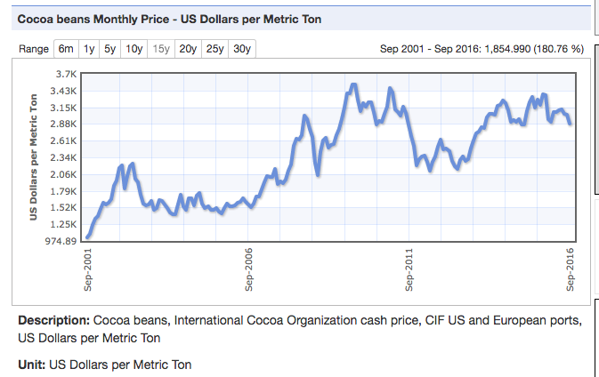
Cocoa bean trees yield approximately 750 kg of ready to sell cocoa beans per hectare in a year. The plant takes between 3 to 5 years to start producing beans. Plants live an average of 25 years.

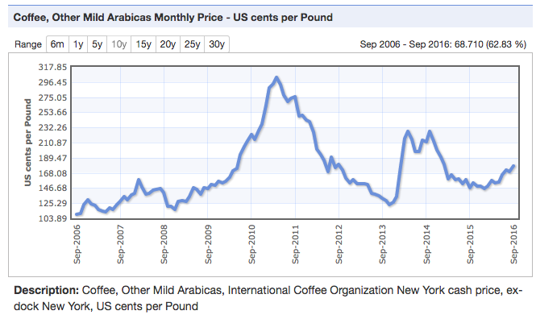
Arabica coffee trees yield approximately 750 kg of clean dry coffee beans per hectare in a year. The plant takes 3 to 5 years to start producing beans. Plants live between 40 to 60 years.

Hectare: a unit of area in the metric system that is equal to 10,000 square meters or 2.47 acres
Pound: A unit of weight and mass used in many English-speaking countries. 1 pound (lb.) is equal to 0.45359237 kilograms (kg).
Letter K: In several unit systems, letter K usually refers to 1000. Example: 1kg = 1000 grams.
1 Metric Ton = 1000 Kg

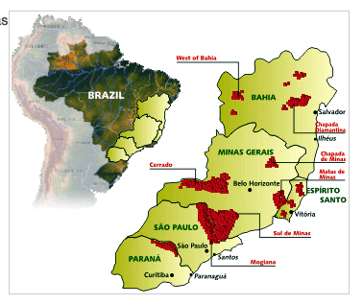
The real-life situation
Your role: Investment consultant at Qatar National Bank.
The situation:
- One of your expats clients has just inherited farming land in Brazil from an old relative. The land is located in Cerrado, a rich agricultural region that produces grains, cotton, maize, coffee and cocoa beans, among other products.
- The inherited land is 800 hectares (Ha.)
- Your client would like to start the business in production of coffee beans and/ or cocoa beans. The farm is ready to start planting immediately.
- Your client is asking for your support in deciding which crops would give more profit.
Your task: Recommending a smart investment in agriculture.

Modeling the real-life situation - Part 1 – Understanding data
You are looking for information related to production of coffee and cocoa beans. Also, you are taking notes to get ready to talk with your client.
1. Read carefully the data page. Write down the missing numbers in your notes:
- The farm will be able to start producing coffee beans or cocoa beans in year_________.
- Letter “K” in 1.0k US Dollars means 1.0K $ = __________ $.
- Last month, the price of one Ton of cocoa beans was ________________.
- Last month, the price of one pound (1 lb.) of coffee beans was ____________

Modeling the real-life situation - Part 2 – Creating a simple model and finding a solution for it.
2. Considering only the prices for September 2016:
a) Compare the amount of coffee beans and the amount of cocoa beans the farm could produce.
b) Determine which crop would be a better investment.
c) Explain your reasoning.

Modeling the real-life situation - Part 3: Creating a more realistic model and finding solutions that make sense.
- Looking at the price data over the years, predict the price of cocoa and coffee beans at the time the plants will start producing.
- Use your prediction to repeat the calculations you did in Part 2.
- Evaluate your results and suggest a sound investment.
- Explain whether or not your answer makes sense in this real-life context.
- How accurate is your answer? Is it possible to improve this model? Briefly explain the accuracy of your answer, and which other data you could use to better answer your client’s question.

